Java Programming Tasks
Output Screenshots
Muhammad Hadi Shahid
Roll No: 2026-CYS(S)-36
Task 1 – Even or Odd
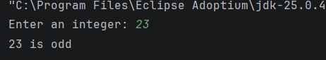
Task 2 – Swap Two Numbers
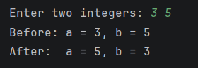
Task 3 – Middle of Three Numbers
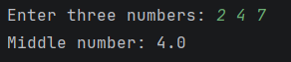
Task 5 – Number Triangle
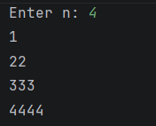
Task 6 – Reverse the Digits
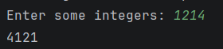
Task 7 – Digit Sum to One Digit
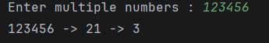
Task 9 – Primes from 1 to 100
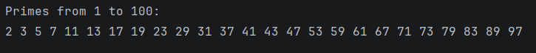
Task 10 – Count Vowels, Consonants, Digits
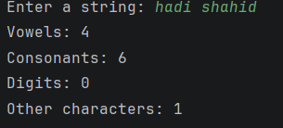
Task 11 – Fibonacci Series
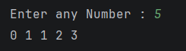
Task 12 – Palindrome Check
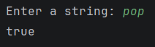
Task 14 – Second Largest Element
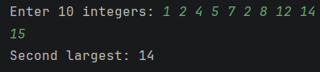
Task 15 – Rotate Array Left
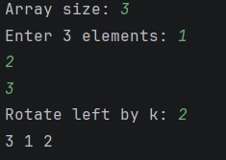
Task 16 – Hollow Diamond
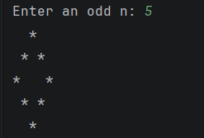
Task 18 – Anagram Check
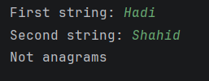
Task 19 – Remove Duplicates
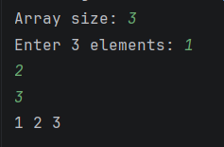
Task 21 – Power x^30 with Multiplication Count
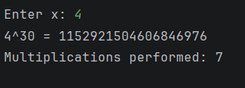
Task 22 – Transpose and Symmetry
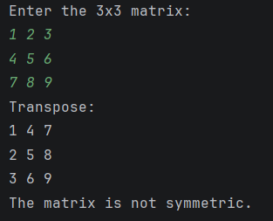
Task 23 – Decimal to Binary
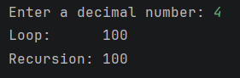
Task 25 – First Non-Repeating Character
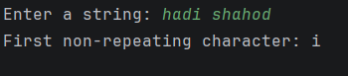
Task 26 – Armstrong Numbers
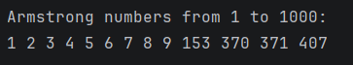
Task 28 – Compress and Decompress a String
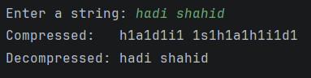
Task 30 – Missing Number
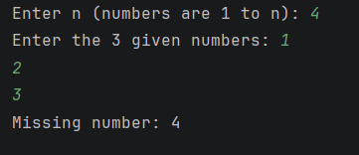
Task 31 – Pascal's Triangle
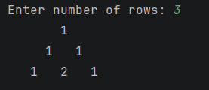
Task 33 – String Permutations
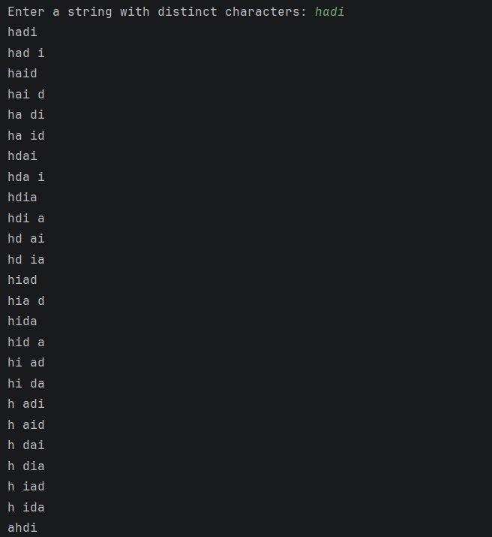
Task 35 – Binary Search with Steps
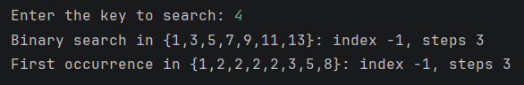
Task 36 – Longest Substring Without Repeating Characters
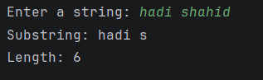
Task 38 – Spiral Order of a Matrix
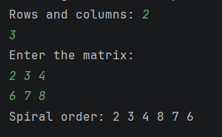
Task 40 – Tower of Hanoi
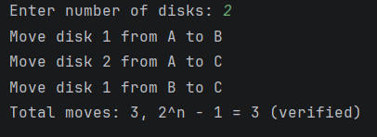
Task 42 – Merge Two Sorted Arrays
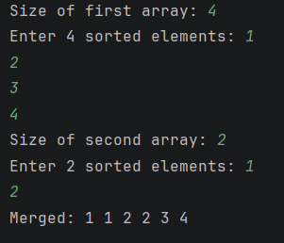
Task 44 – N-Queens (N = 6)
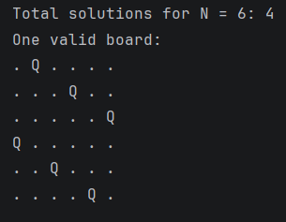
Task 46 – Maximum Subarray Sum
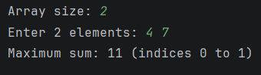
Task 48 – Sudoku Validation
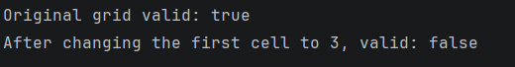
Task 50 – Factorial of 50

